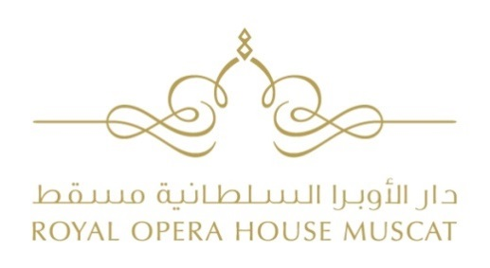

OPEN HOUSE - TANGO CLASS
March 2 and 3, 2018

APPLICATION FORM
Name ............................................................... Surname ...............................................................
Date and Place of Birth………………………………………………………………………………………………………………
Nationality.......................................................................................................................................
Address ............................................................................................................................................
City .................................................. PO BOX……………...…………………..Postal Code..........................
Phone.............................................................. E-mail....................................................................

Group A – intermediate & advanced  March 2, Friday: 4:00 to 5:30 pm  March 3, Saturday: 10:00 to 11:30 am | Group B – beginner  March 2, Friday: 6:00 to 7:30 pm  March 3, Saturday: 12:00 to 1:30 pm

ADVANCED □ BEGINNER □
INDIVIDUAL □ IN COUPLE □ (with ___________________________)

Date ……………………………………… Signature……………………………………………………………..

□ Tick here if you wish to receive information by e-mail from the Royal Opera House Muscat about Education and Outreach activities.

The Application Form must be completed legibly and in full, and sent on or by 10th February to:
education@rohmuscat.org.om

